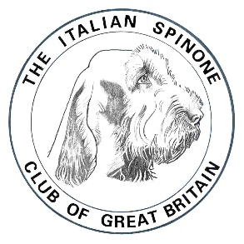
The Italian Spinone Club of Great Britain

Hon Field Trial Secretary
Alix Johnson
1 Ducks Cottages, Nether Wallop, Stockbridge
Hants SO20 8HE
01264 781913
3girlsandtrev@lineone.net

GROUSE POINTING TEST
Saturday 25 March 2023
Walshaw Moor, West Yorkshire HX7 7AT
By kind permission of R Bannister Esq. and Jonathan Lord

There will be runs for 15 Junior HPRs.
ISCGB members and Spinoni will be given priority.
Adult HPRs/non-members may apply and, in the absence of a full card of Juniors, a draw will be made.
One dog per handler, unless under subscribed.

Judges: Eddie Kania and Rob Irvine

Entries Close: Friday 10th March 2023

Meeting: 845 am for 9 am start

JUNIORS: For dogs over 6 months of age and under two years of age on 1st January 2023

ADULTS: For dogs over two years of age on 1st January 2023

Credit should be given to dogs which point grouse (all species), snipe and golden plover. They should not, however, be penalised for failing to point snipe or golden plover.

Dogs will be assessed at the end of the day, and those considered worthy will be graded: EXCELLENT, VERY GOOD or GOOD.

Dogs will be run singly into wind for a minimum of ten minutes. They will be allowed one minute to settle down. Priority will be given to game finding and therefore natural working ability will be credited before steadiness. No dog will be eliminated unless out of control.

FEES: £20 for members and £25 non-members.
Entries, together with a correct fee, must be sent by the closing date.
Cheques/Postal orders made payable to ISCGB.
Email entries will be accepted, and bank transfers are possible on confirmation of a run.
Bank Details: (Lloyds Account Number 03845457 Sort Code 30-96-17).

Alix Johnson
ISCGB FT Secretary
1 Ducks Cottages
Nether Wallop
Stockbridge
Hants SO20 8HE
Telephone: 01264 781913 Email: 3girlsandtrev@lineone.net

